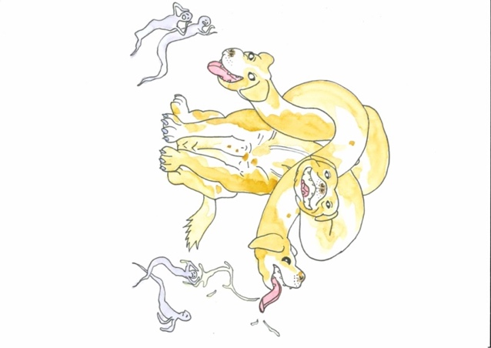**Encircle the right answers**

1. You and your friends are fighting in the Underworld against Cerberus. Your friends must throw rocks and spears at his heads: ‘Friends, βαλλε/βαλλετε!’

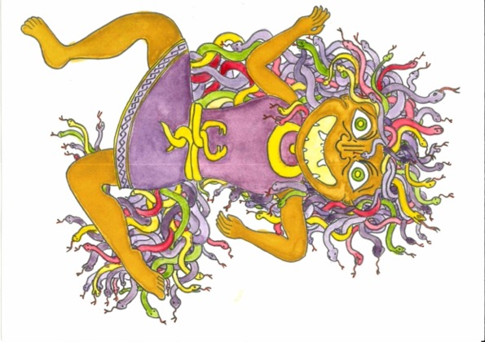

2. Μεδουσα comes over to you. You squeeze your eyes and shout that she must stop: ‘Mεδουσα, παυε/παυετε!’

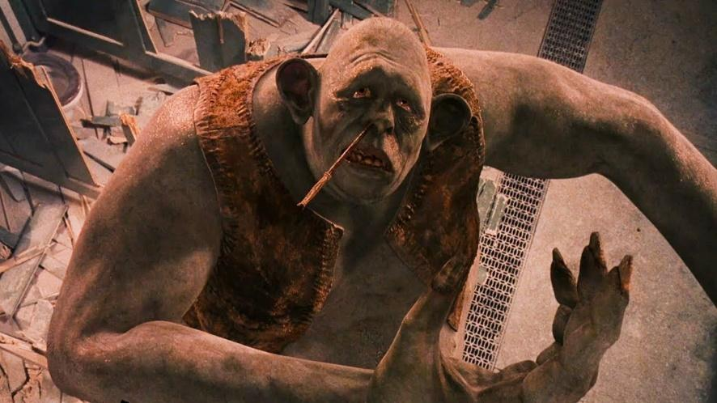

3. A γιγας holds your best friend in his hand. A huge stick falls on the head of the γιγας. You are hoping he is going to fall: ‘γιγας, πιπτε/πιπτετε!’

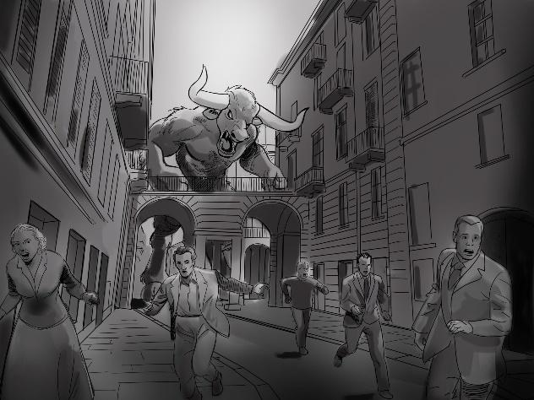

4. A big μινωταυρος attacks the city. All the citizens must flee. ‘People, τρεχε/τρεχετε!’

5. Because you thought the Greek lessons were the best, you want to hold a party with you best friends: ‘χορευε/χορευετε!’