Chance cards
Athena  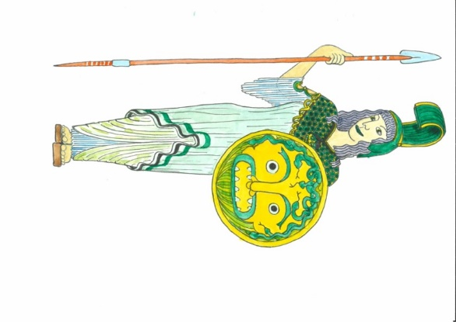  Odysseus is the favourite human being of the goddess Athena.  Blue may go immediately to a blue square!  The other colours stay where they are. | Poseidon  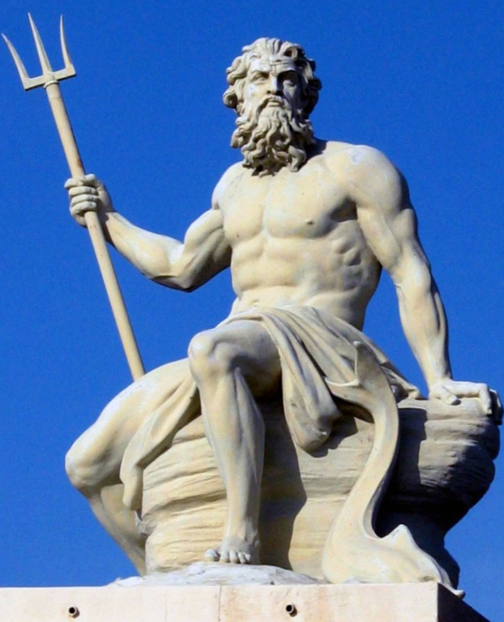  Ouch, Poseidon cannot stand Odysseus!  Blue has to skip a turn.  The other colours may move 3 squares in whatever direction they want.
Enkidu  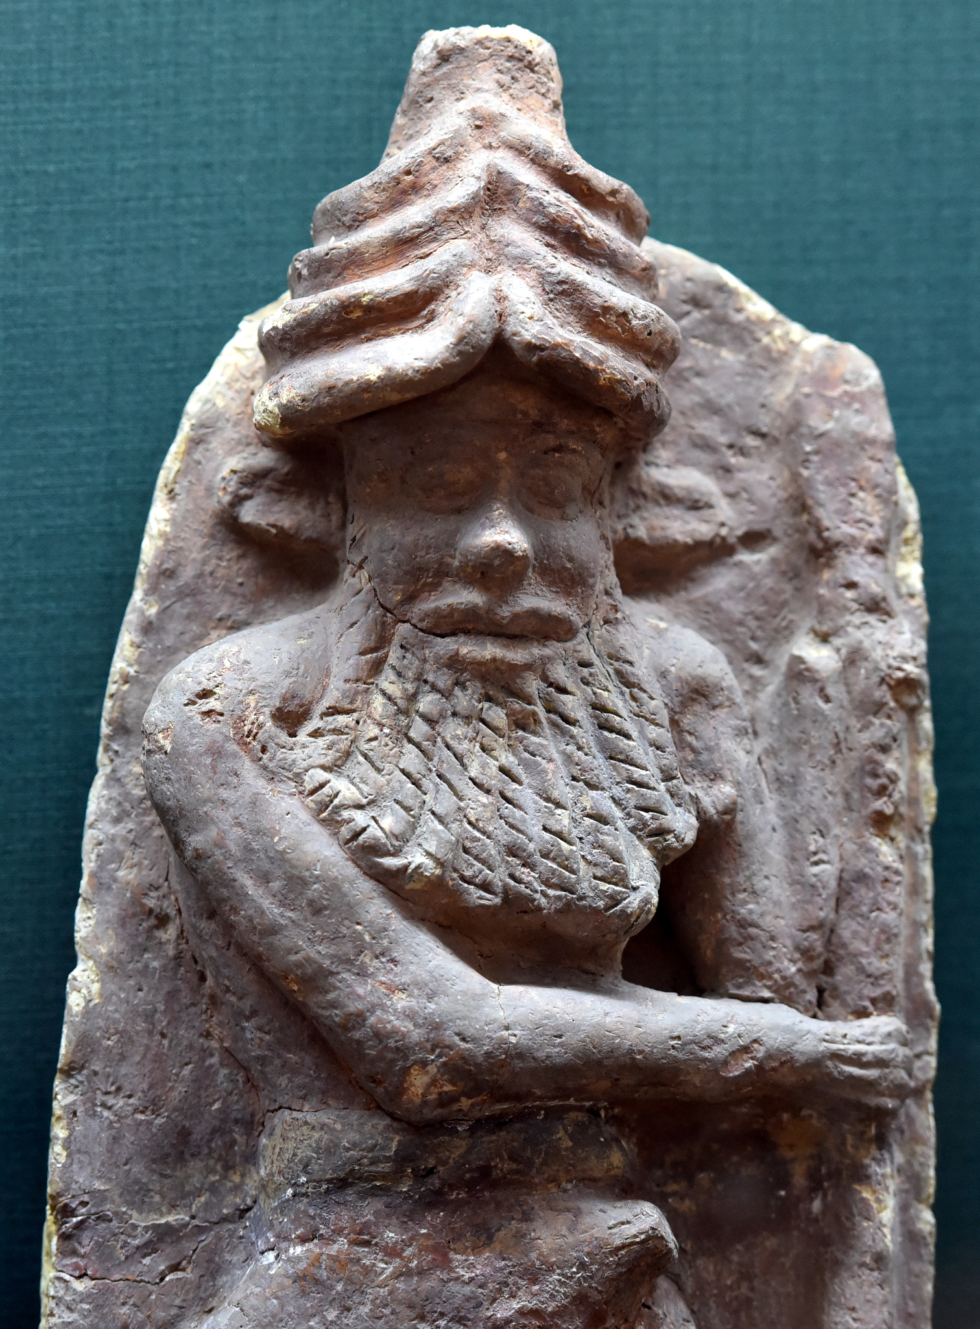  Enkidu is the best friend of Gilgamesh.  Red may go immediately to a red square! The other colours stay where they are. | Shamhat  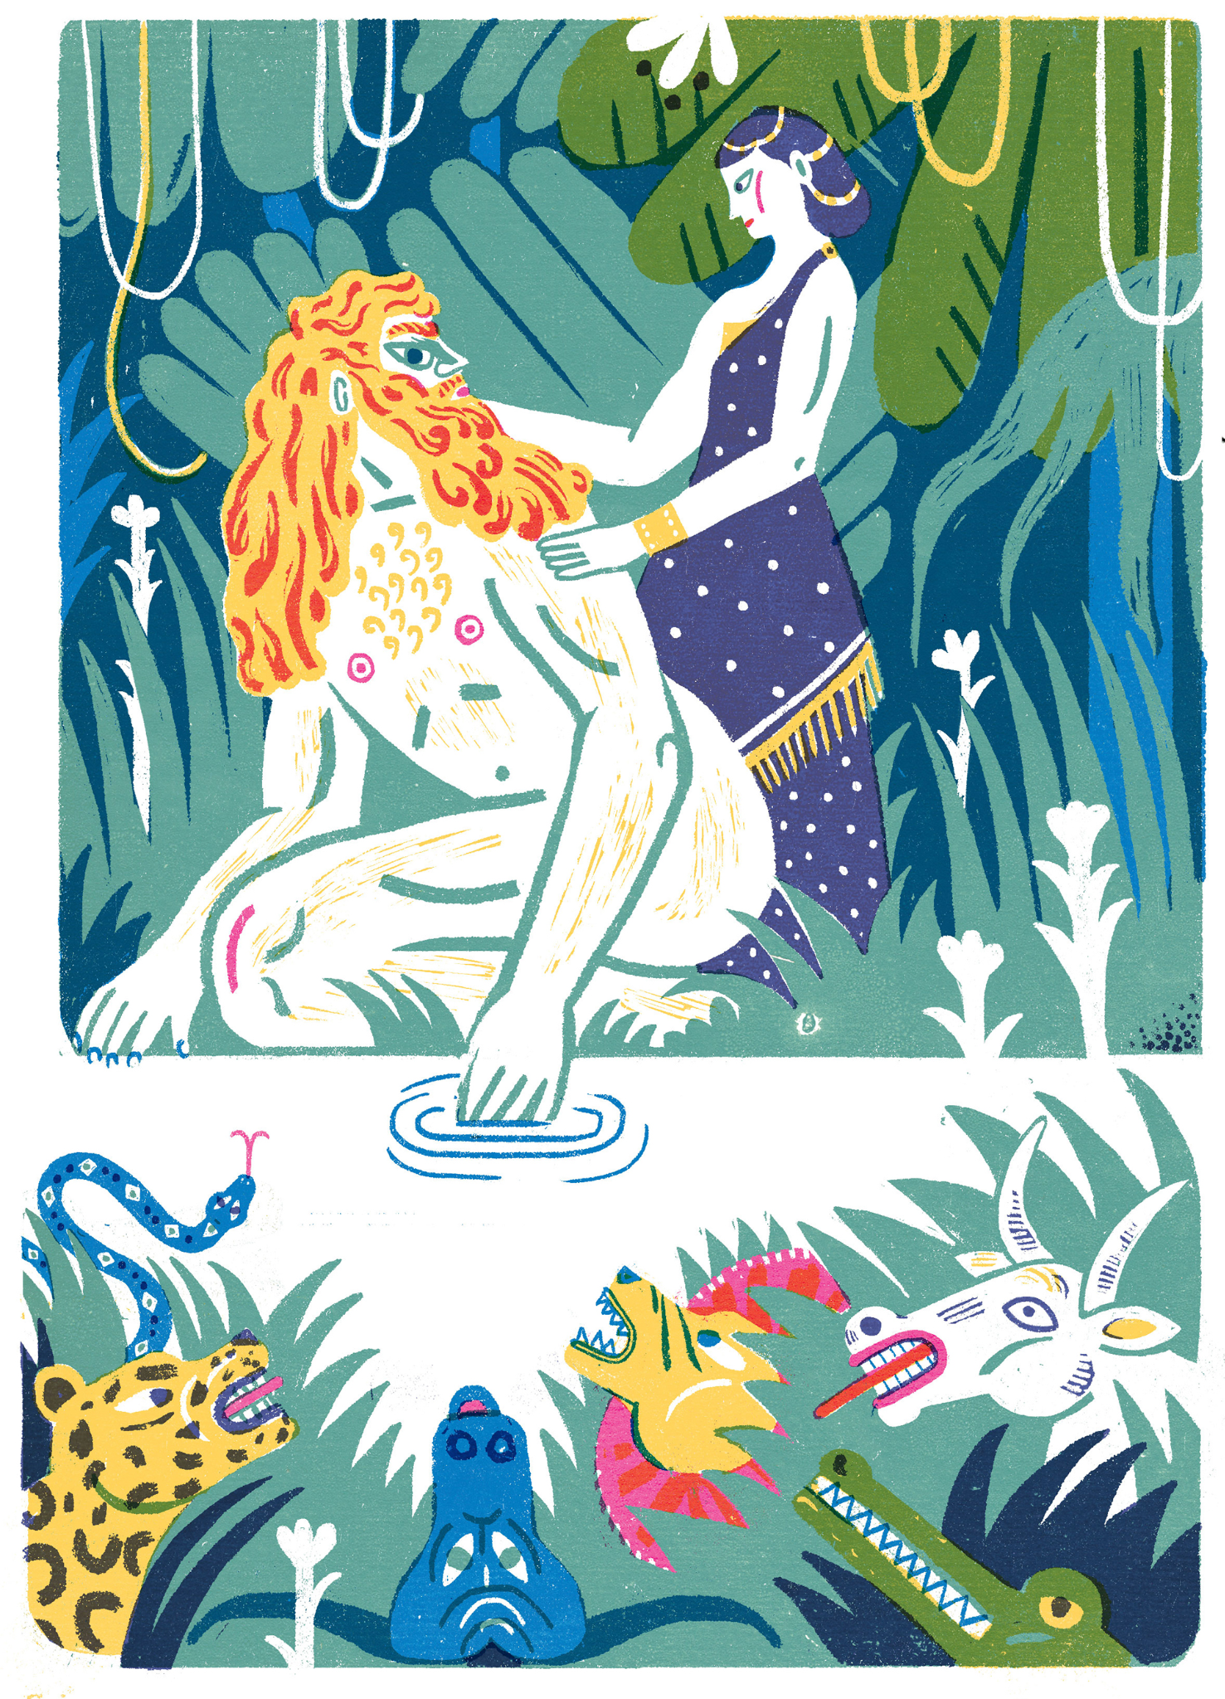  Shamhat has her eye on Gilgamesh. Gilgamesh forgets that he must go home.  Red has to skip a turn.  The other colours may move 3 squares in whatever direction they want.

Sindbad  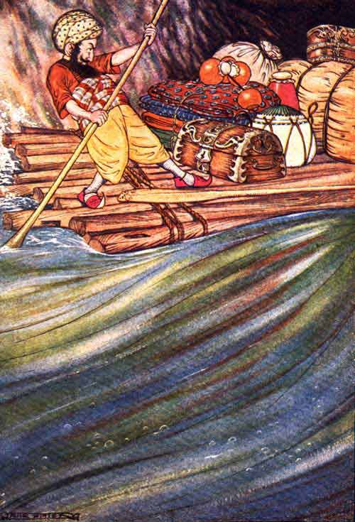  The tough sailor Sindbad can sail through every storm.  Green may go immediately to a green square!  The other colours stay where they are. | De Reus  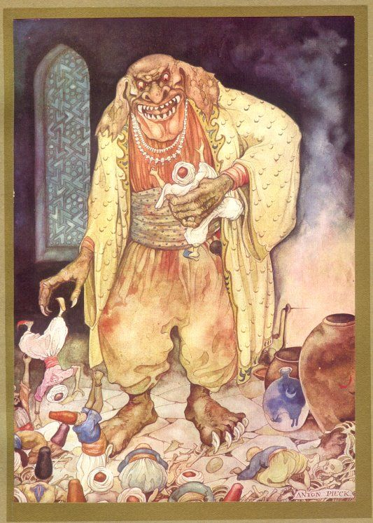  Oh no! The giant blocks the path.  Green has to skip a turn.  The other colours may move 3 squares in whatever direction they want.

Tasks

Odysseus
The war in Troy  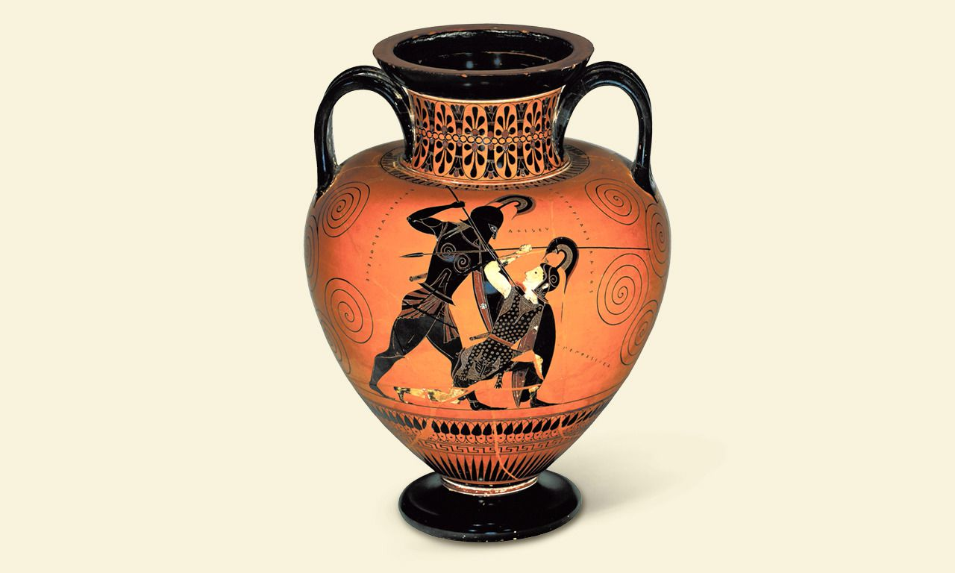  After 10 years of war, Ὀδυσσευς can finally go home.  He wishes to be with his παιδιον fast.  What would be the first thing you do after 10 years of war? | The cyclops Πολυφημος  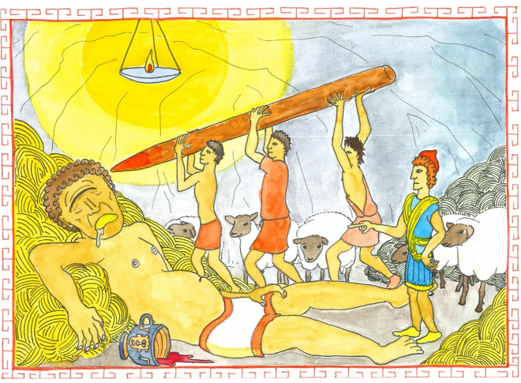  Ὀδυσσευς petrified Πολυφημον.  The γιγας only had one eye.  This was his weakness and Ὀδυσσευς noticed that quite well.  What is your weakness?
Αἱδης  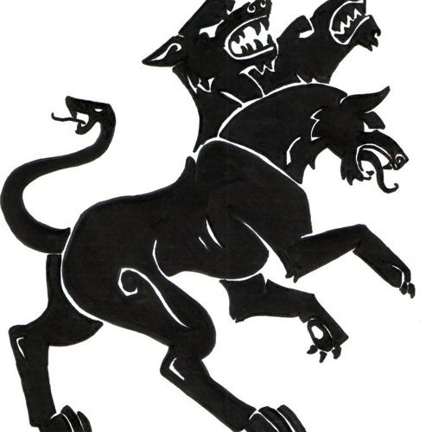  Who would you like to meet in the underworld? Your great-grandfather? The first man on the moon?  Tell who you would pay a visit and why. | The sorceress Κιρκη  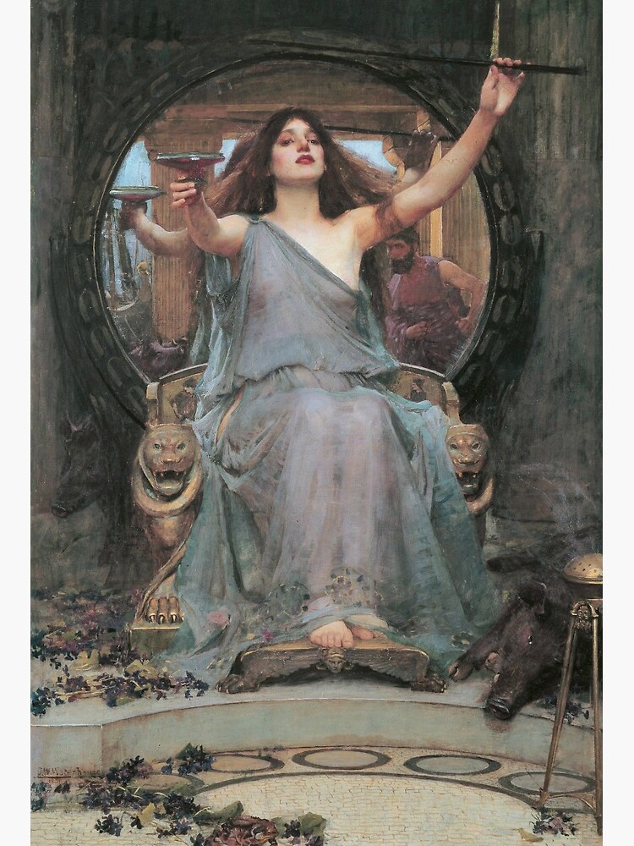  Κιρκη is the sorceress who has turned your φιλον into a pig.  In which animal would you change and why?

Gilgamesh
Enkidu and Gilgamesh  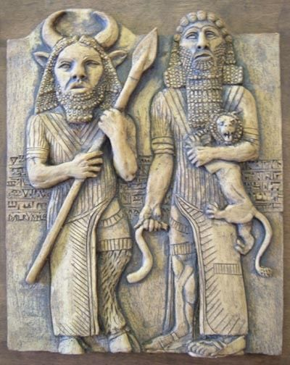  Enkidu and Gilgamesh must go on an adventure together. They become each other’s φιλος.  Which φιλον would you take with you on an adventure? Why? | The γιγας Humbaba  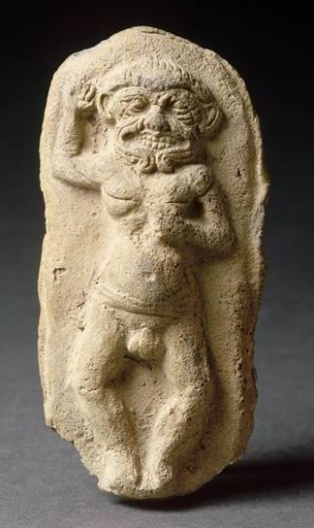  Suddenly, the dreadful γιγας stands in front of Gilgamesh.  You are scared, but know that also the gods like him.  What will you do? Do you attack him or do you keep him as a friend?
De onderwereld  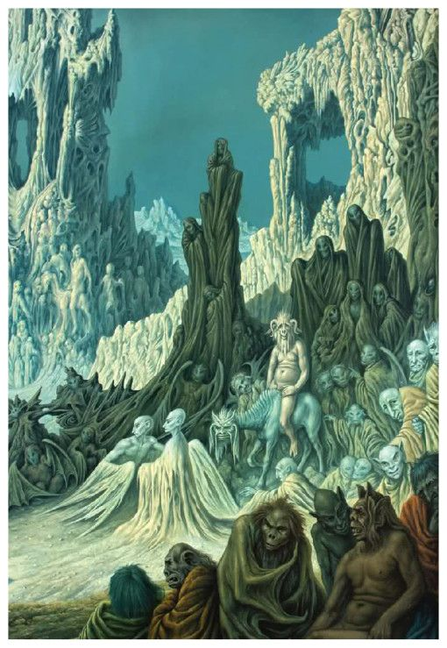  Gilgamesh pays a visit to Enkidu in the Underworld.  If you got the chance to pay someone a visit in the land of the dead, who would you like to meet? Why? | De godin Ishtar  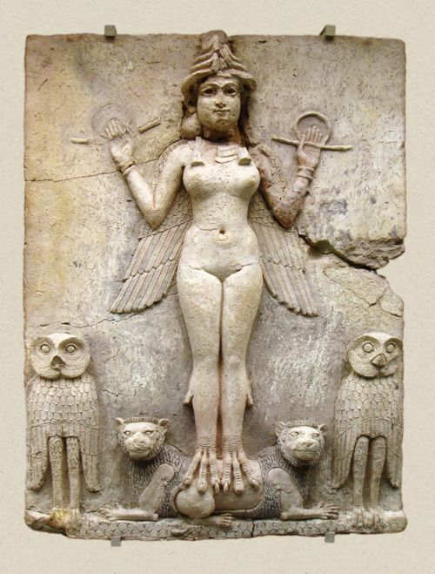  De goddess Ishtar changed a man into a wolf. And she changed another man into a frog.  In which animal would you change the goddess into to take revenge?

Sindbad

The πατηρ dies    When the father of Sindbad died, he left a lot of money behind. Sindbad felt so much sorrow, he tried to buy his happiness. He spent all his money!  Can you understand the situation Sindbad was in? What do you do when you are sad? | 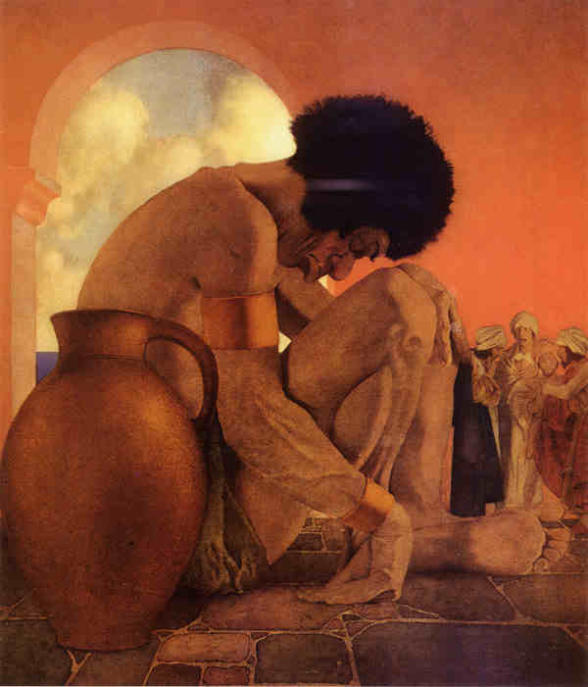  The γιγας  Σινδβαδ came across a giant on one of his trips. He knew that he was not strong enough, so he had to be smart!  Whilst the giant was sleeping, he plucked out his two eyes, so that the giant would not be able to see him and then devour him.  Do you sometimes have to be smart because you are not (that) strong? When?
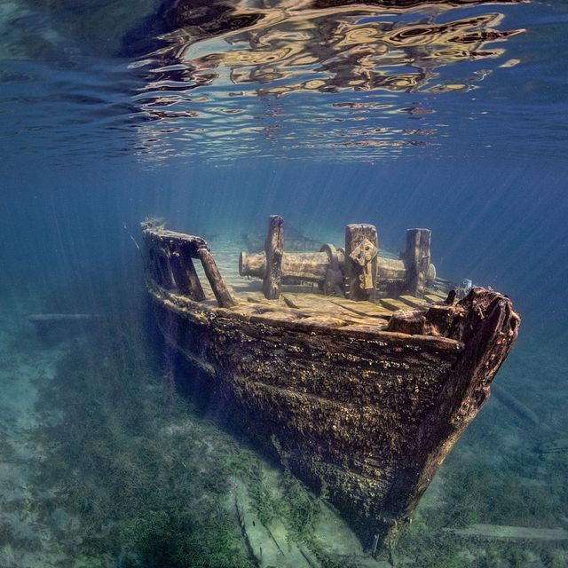  Shipwreck  Ouch! Sindbad has been in a storm and now his ναυς has sunk. He has swum to the shore, but does not know what to do now…  What would you do if you were Sindbad? | 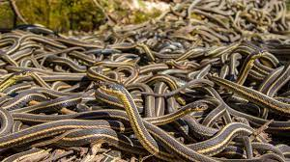  δρακωνες in the ravine  Poor Sindbad! He is in a pickle again. He has fallen down a ravine filled with snakes. How will he get out here?  Can you help him? Or do you fear the δρακωνες? Why (not)?

