**Board game questions**

Give the name of the monster (in Greek or in English):

**1. 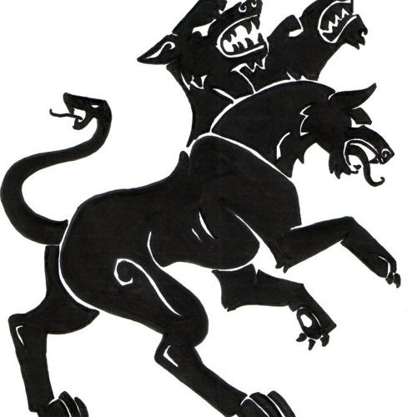.................................................................**

**2. 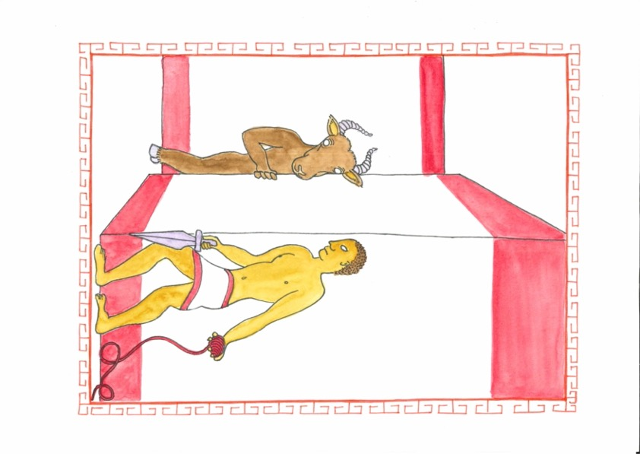 …………………………………………**

**3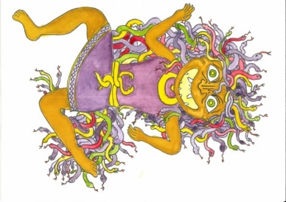 .........................................................**

**4.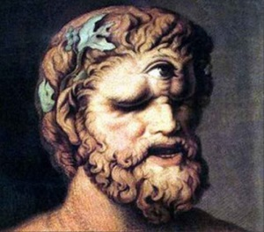 ………………………………………**

**Encircle the right answer.**

1. I am Ἀργος/Ἀργον, the dog, and I like eating cookies.
2. I love learning Greek, so that’s why I like going to the σχολη/σχολην.
3. In the Underworld, Κερβερος guards a ψυχη/ ψυχην.
4. Μεδουσα turns everyone who looks in her eyes, into a λιθος/λιθον.
5. Μεδουσα wants to petrify you, but you run away fast and shout: “Παυε/ Παυετε”.
6. The Μινωταυρος wants to devour you. You shout at your best friends: “Τρεχε/Τρεχετε”.
7. The children of your class want to dance. The teacher says: “Χορευε/Χορευετε”
8. My μητηρ is my brother/mother.
9. My ἀδελφος is my brother/daughter.
10. A παιδιον is a child/island.

**Answer these questions (you may use the handouts of the previous lessons)**

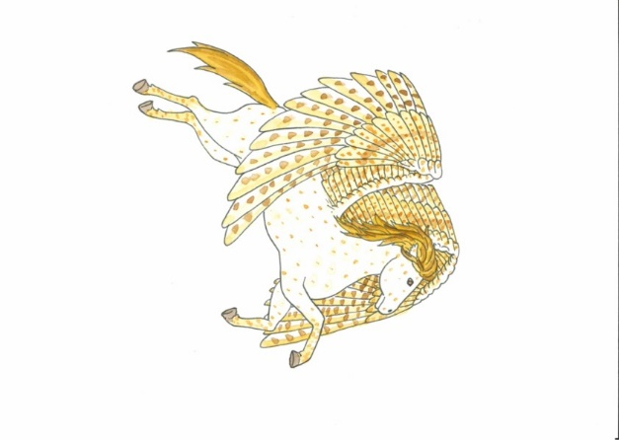

1. Which English word can you make with βιος? ……………………………………………………………..
2. What was the name of the child of Μεδουσα ? ……………………………..
3. 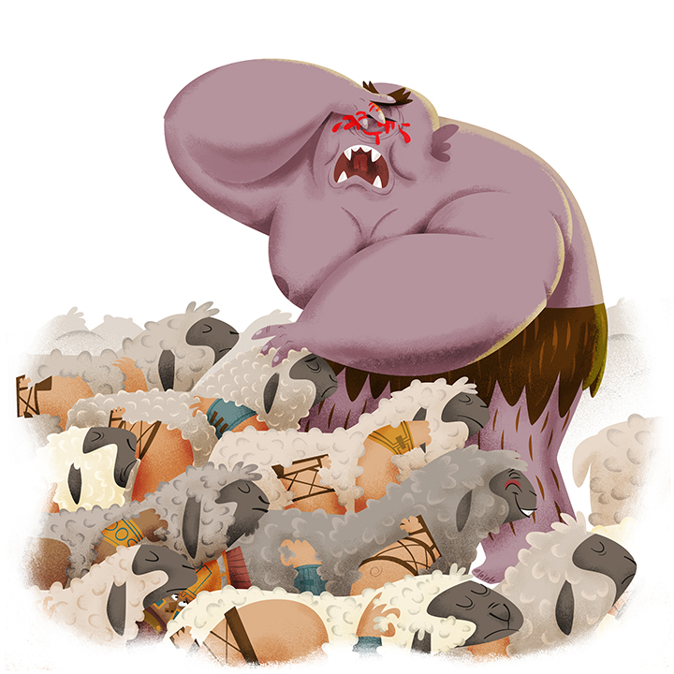What dreadful things did the heroes Σινδβαδ and Ὀδυσσευς do to the cyclops? ……………………………………………………………
4. Tell your team members in short what happens in this picture.
5. When did the ancient Greeks live?

……………………………………………………………

1. What is the fourth letter of the Greek alphabet? ……………………………………………………..
2. How do you say ‘mother’ in French? ……………………………………………...
3. On the border of which 3 continents did ancient Greece lie?

………………………………………………………………………………………………

1. 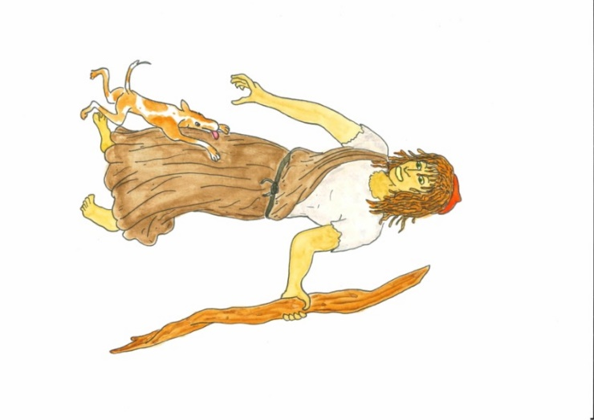What is the name of the dog of Ὀδυσσευς ? ………………………………………….
2. What did the Greeks use clay pots for?

…………………………………………………………

…………………………...

1. What is a δενδρον ? …………………………………………………………...
2. What does the Greek word φωνη mean? (hint: I can hear a … on the phone)

…………………………………………………………………………………………..

1. Ὀδυσσευς is a good φιλος of Ἀχιλλευς. What does φιλος mean?

……………………………………………………………………………………….

1. Which English word can you make with the Greek words θερμος and μετρον?

……………………………………………………………………………………….

1. A dinosaur is a very dreadful …………………………………..
2. What does μικρον mean? ………………………………………………………
3. Write your own name in Greek. (hint: use the endings: -ος, -η or -ον)

………………………………………………………………………………………..

1. Write the name of your neighbour in Greek. (hint: use the endings: -ος, -η or -ον)

………………………………………………………………………………………..

**Write these words in Greek**

* gigas = …………………………………………………………………..
* filos = ……………………………………………………………………..
* chaos = …………………………………………………………………...
* pontos = …………………………………………………………………..
* mega = …………………………………………………………………….
* logos = ……………………………………………………………………..
* epsilon = …………………………………………………………………...
* Poseidoon = ……………………………………………………………….
* Zeus = ……………………………………………………………………...
* Pallas = ……………………………………………………………………..
* Odusseus = ………………………………………………………………...