|  |  |
| --- | --- |
| βιος | λογος |
| μετρον | θερμος |
| φιλος | σοφος |
| γη | γραφη |
| λογος | ψυχη |
| μικρος | σκοπος |
| δεινος | σαυρη |
| dinosaur  What Is a Dinosaur | Dinosaurs for Kids | DK Find Out | thermometer |
| philosopher  3 philosophers set up a booth on a street corner – here&#39;s what people asked | biology  Online IB Exam Prep Course Biology | Lanterna Education |
| geography  Geography Stickers - Free education Stickers | microscope |
| psychology |  |

|  |  |  |  |
| --- | --- | --- | --- |
| πατηρ | father | brother | Schwester |
| θυγατηρ | mother | daughter | Bruder |
| ἀδελφη | fils | son | Tochter |
| soeur | enfants | Vater | Kinder |
| mère | frère |  |  |

## 

## 

## 

## 

## **Μεδουσα’s family tree**

Fill in these names:

**φορκυς πηγασος ποντος σθενω κητω**

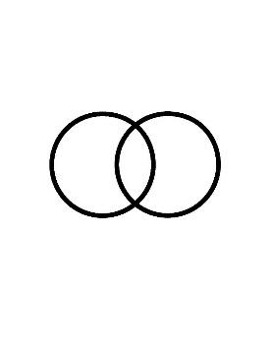

γαια

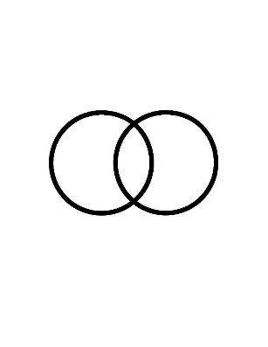



μεδουσα



**Story of Medusa**

**(for the teacher only: reads aloud)**

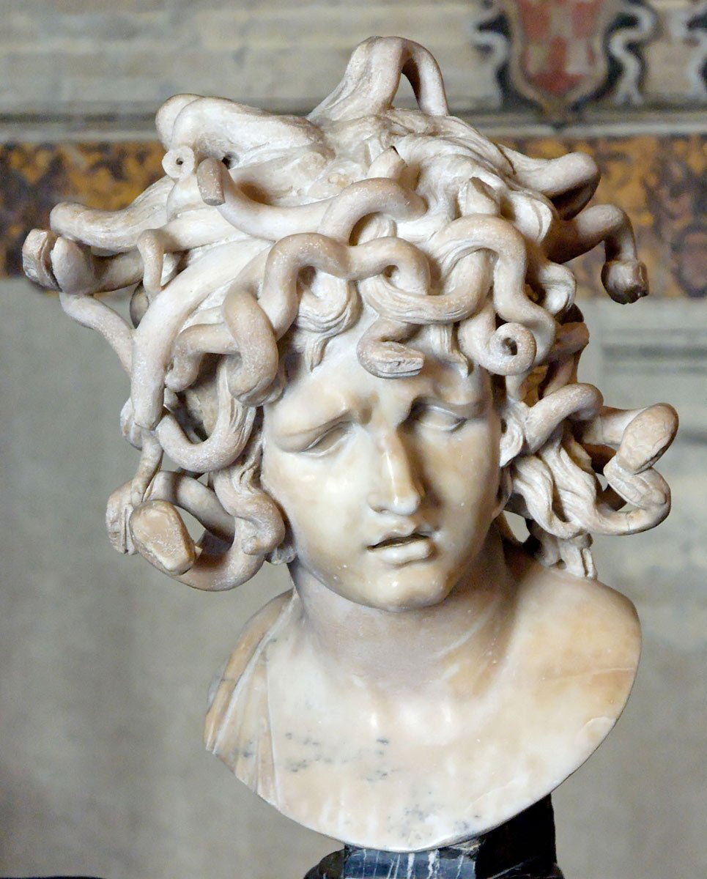Gaia - or Mother Earth - is one of the oldest Greek goddesses. She is the goddess of the Earth. Together with Pontus, the god of the seas around the earth, she had many children. Their sons and daughters were all kinds of sea monsters and sea gods. Two of those children were Phorcys and Ceto. Phorcys is a sea god, Ceto a scary monster who, according to the Greeks, was responsible for all dangers at sea. Ceto was married to her brother, Phorcys. After all, they were both children of Gaia and Pontus. Phorcys and Ceto had a daughter together, called Medusa. We know Medusa as a Greek woman with snake hair, but that was not always the case... The young Medusa was a very beautiful girl and everyone was jealous of her beauty, even goddesses. Phorcys and Ceto had another daughter, Stheno. She was Medusa's sister.

One day, Medusa was in the temple of Athena to make a sacrifice to the goddess. However, the sea god Poseidon was also in the area and had spotted the beautiful Medusa. Poseidon approached her and kissed her, without Medusa's consent. Medusa fled from the temple. Athena, who always keeps an eye on her temples, had seen all this happening. Athena was jealous and thought of a punishment that would take away Medusa’s beauty. She turned Medusa's hair into wriggly snakes on top of her head. Since then, Medusa has turned anyone who attempts to look her in the eye into stone. So her mother Ceto and her grandfather Pontus had to watch out that they did not look into Medusa's eyes; otherwise they would be turned into stone statues!

Medusa, with her dangerous gaze, lives in a big house far away in the woods, where nobody dares to come. One day, however, the brave hero Perseus came to visit Medusa. He had been given the task of beheading Medusa and bringing back her head. Perseus had come up with a clever little plan to do this. To avoid looking Medusa directly in the eye and being turned into a stone statue, he used his shield as a mirror so that he could look at Medusa from a safe distance. He came closer and closer and managed to chop off her head with all the snakes, put it in a sack and went on his way. From now on, Perseus used Medusa's head as a weapon to transform all his enemies into stone statues.

When Perseus cut off Medusa's head and Medusa died, thick drops of her blood fell to the ground. From that blood, the child of Medusa was born. That child was the winged horse Pegasus. Pegasus is a divine horse and helps the gods and heroes in their battle to defeat monsters.

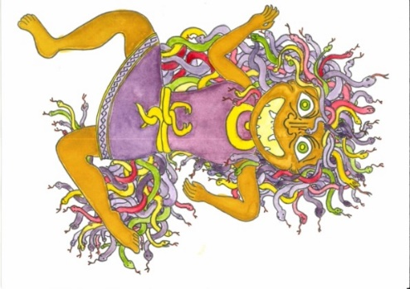**A clay pen holder**

Today, we’re not working with wood from a δενδρον, but with clay!

Medusa was a γυνη with the κεφαλη of a δρακων who could turn people to stone with her gaze.

Therefore, in Medusa style, we make a pen holder in clay!

Follow the steps below:

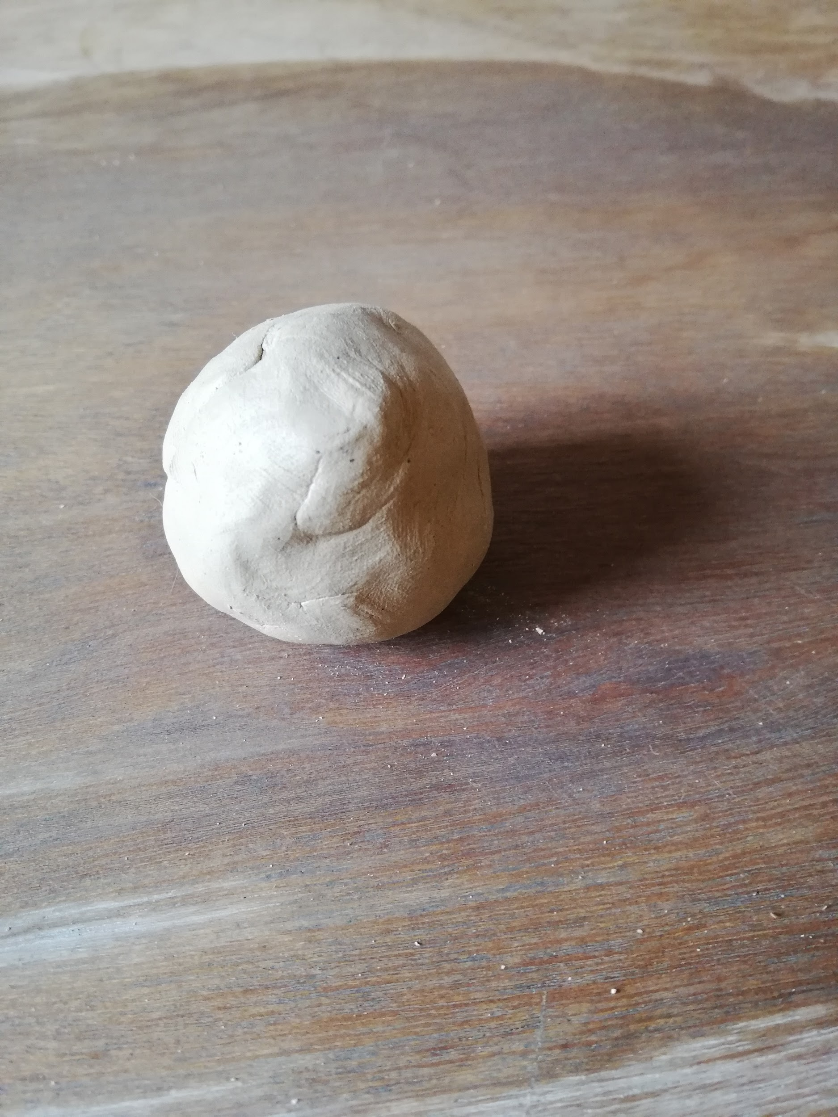

**STEP 1**

Make a ball of the clay and generate a good heat by rubbing it between your hands.

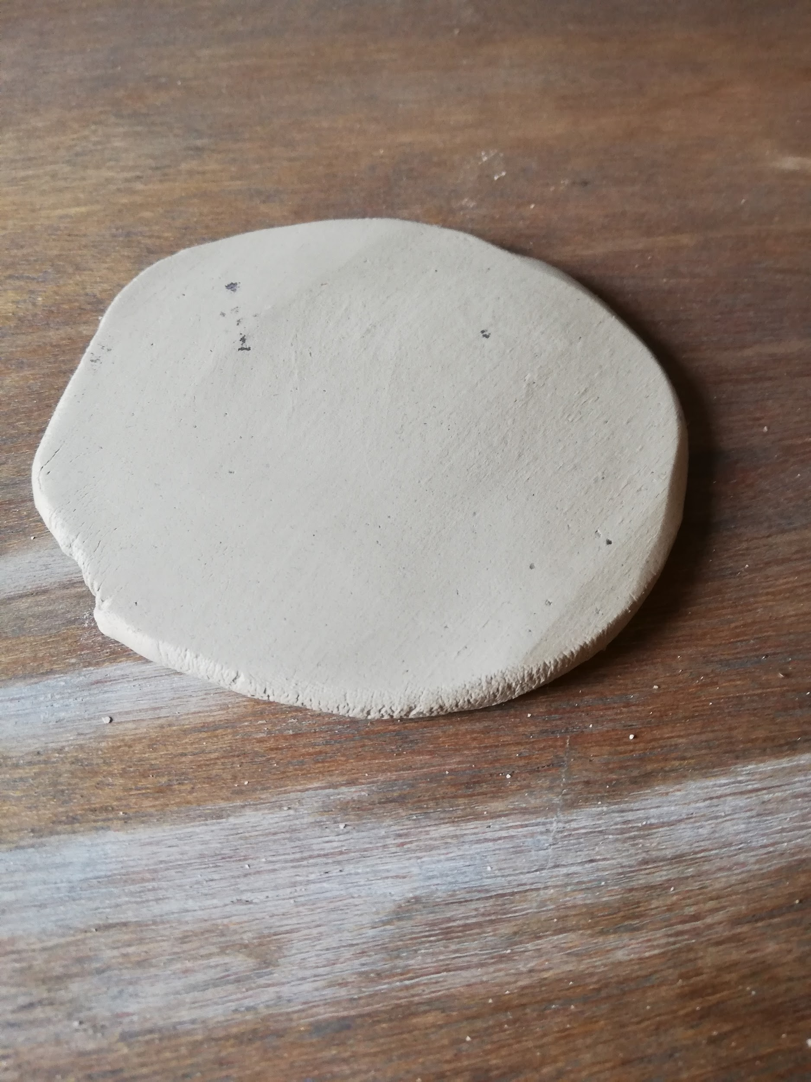

**STEP 2**

Flatten the ball and press it with much δυναμις!

(Tip: Don't know what δυναμις means? Think of the

English word dynamic or ask your teacher what it means.)

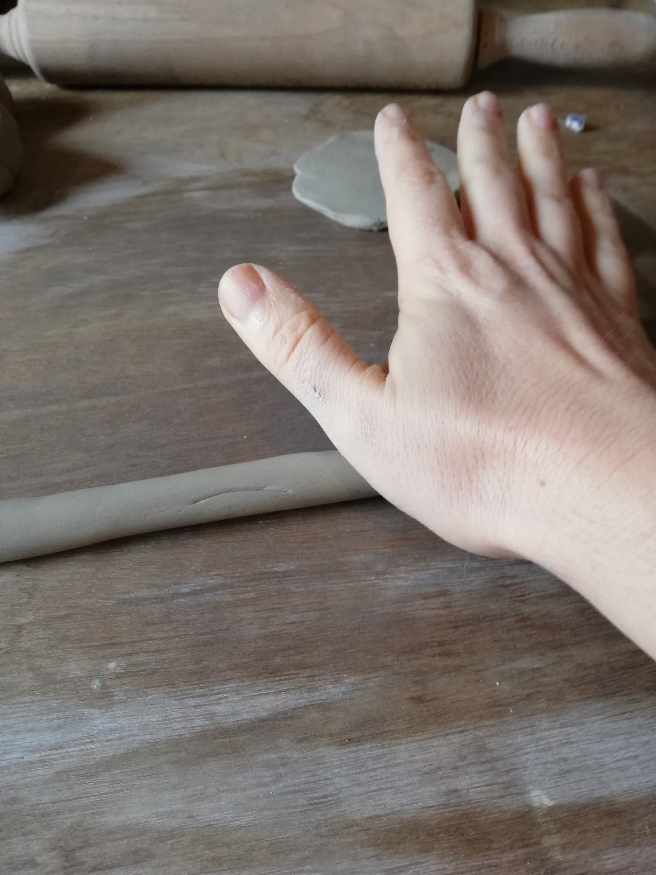

**STEP 3**

Set the flat clay aside.

Roll up another piece of clay to form a

δρακων-shaped figure.

(Note: a δρακων is not a dragon!)

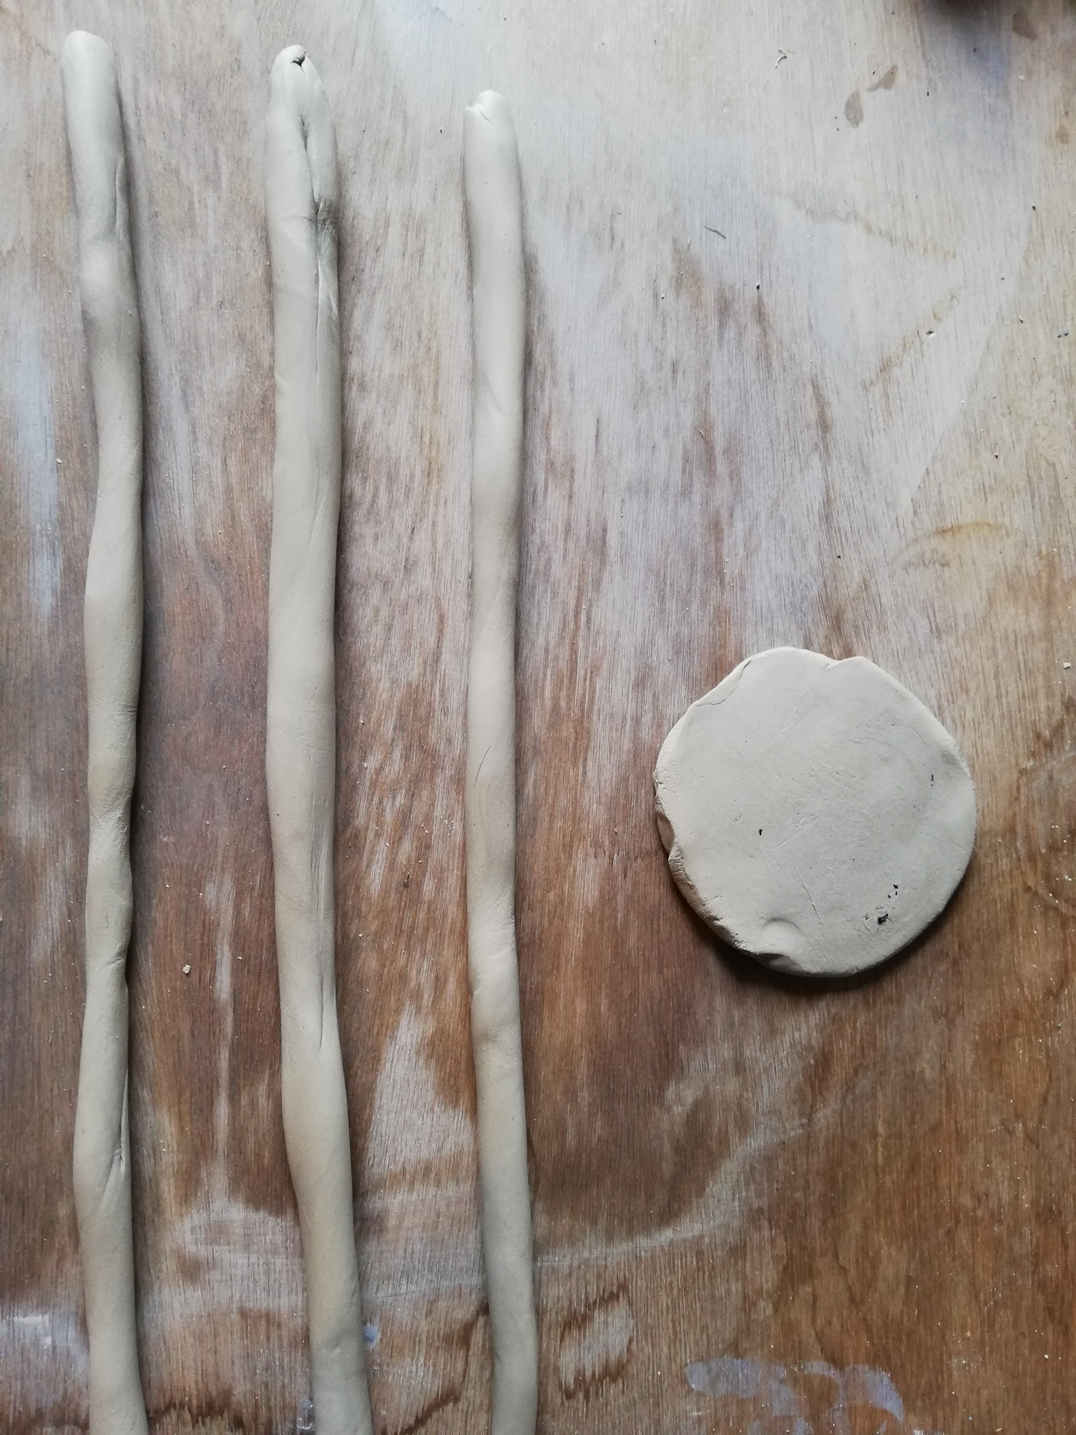

**STEP 4**

Repeat step three three times so that you have one flat pancake and three δρακων-shaped figures as shown.

(Tip: if you’re not sure if you did it correctly or if you need help, ask a teacher for help!)

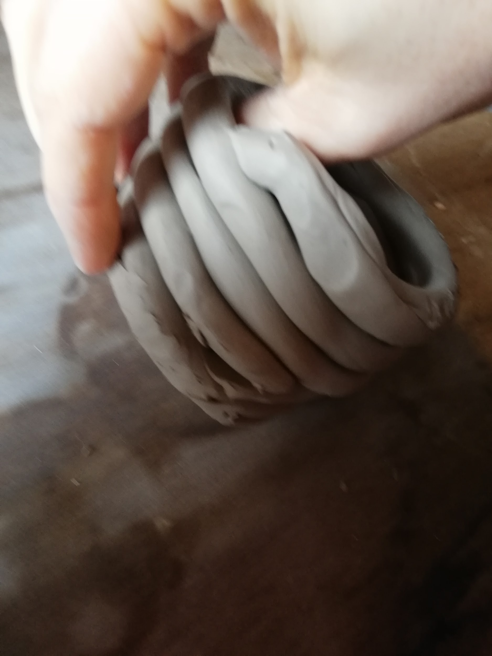

**STEP 5**

At the bottom, place the flat pancake, this is the base of your pen holder.

Above it, coil the three δρακων-shaped rolls on top of each other.

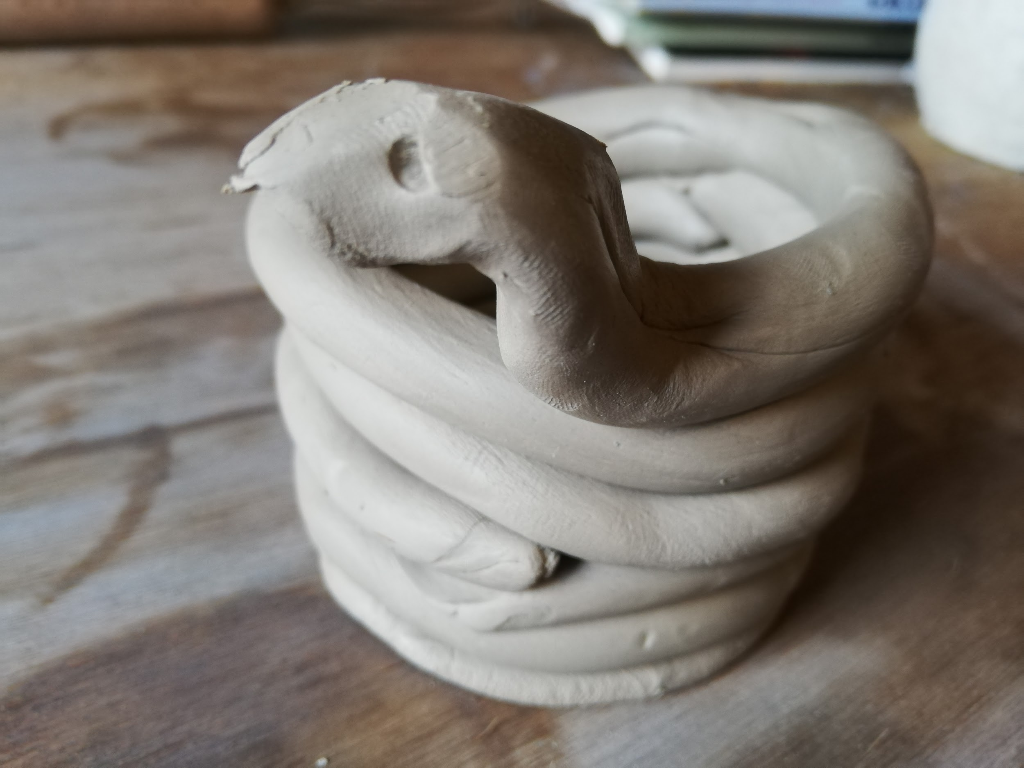

**STEP 6**

Now it's time to make a κεφαλη for the

for the δρακων!

Do this on the top of your

figure as in the picture.

Eyes can be made by poking two holes

holes with a pen or stick.

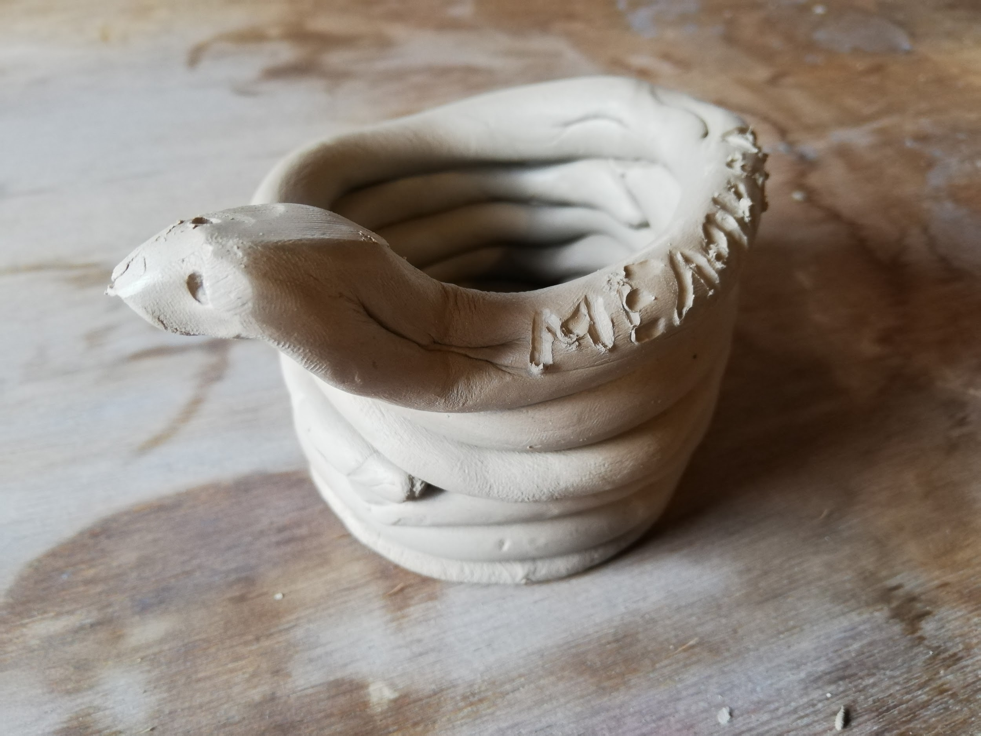

**STEP 7**

Yes, you’re almost there! Finish the δρακων pen holder by inscribing your name on it! That way, everyone will know it's yours. Your name? Of course you write it in Greek (;

Congratulations, that looks καλος!

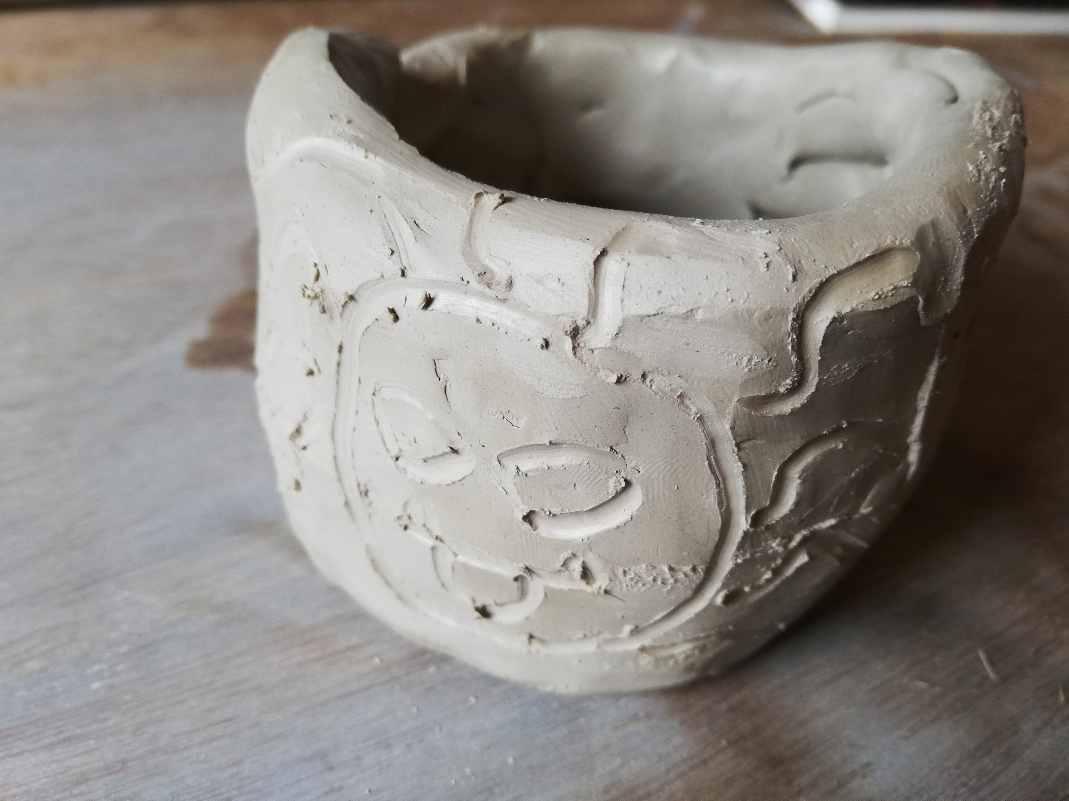

**STEP 8**

Would you rather make a drawing on the jar? Follow the instructions above and smooth the outside with your fingers.

Decorate the jar with a stick or pen.

You can draw Medusa or another monster we covered in the lesson.

**Extra exercises**

1. **Circle the correct word. Tip: Have a look at the help line on page four.**

Ἀριαδνη / Ἀριαδνην gave a ball of wool to Theseus.

Polyphemos threw a λιθος / λιθον at Odysseus' boat.

I’m reading a βιβλιον / βιβλιον.

Κερβερος / Κερβερον guards the entrance to the underworld.

My best φιλος / φιλον is in the same class as me.

My ἀδελφη / ἀδελφην plays the piano.

Odysseus stabbed the ὀφθαλμος / ὀφθαλμον of Polyphemos with a burning pole.

|  |  |
| --- | --- |
| Subject | Direct Object |
| Ἀριαδν-**η** | Ἀριαδν-**ην** |
| Μινωταυρ-**ος** | Μινωταυρ-**ον** |
| παιδι-**ον** | παιδι-**ον** |

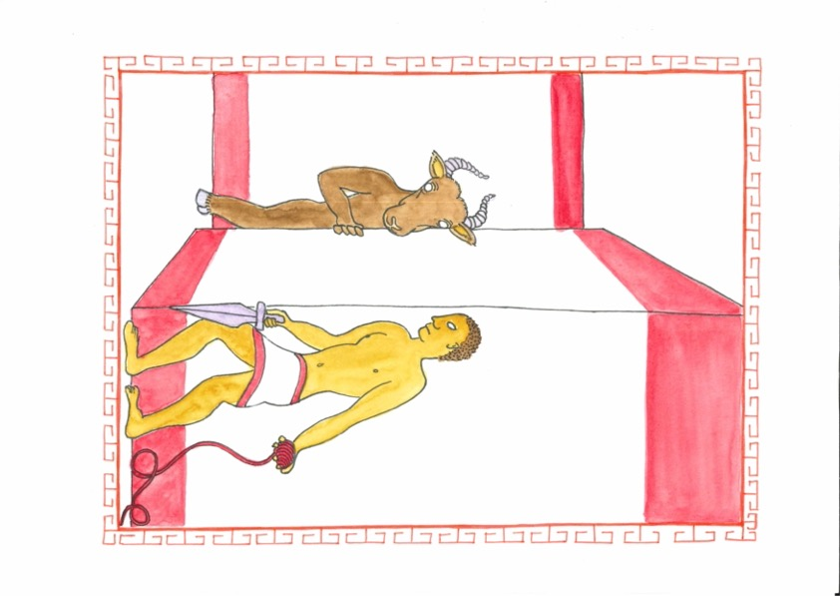

1. **Look at the family tree of the Greek gods. Indicate the right word in the sentences below.**

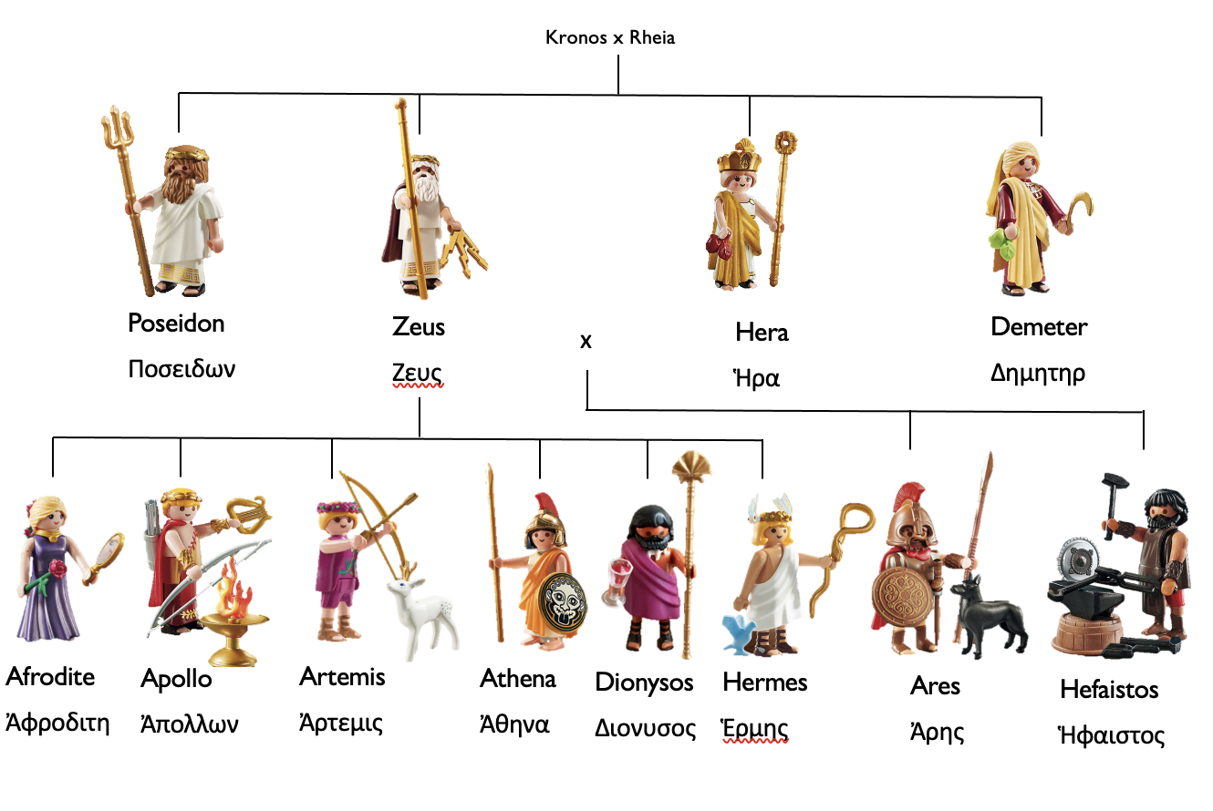

1. Δημητηρ is the ἀδελφος / ἀδελφη of Ποσειδων.
2. Ἀθηνα is the μητηρ / θυγατηρ of Ζευς.
3. Ζευς is the πατηρ / ἀδελφος of Ποσειδων.
4. Ἑρμης is the υἱος / ἀδελφος of Ἀφροδιτη.

**3. Write some sentences with Greek words about the Greek gods.**

**Tip: Look at the family tree of the gods on page 3, and use the help line.**

**Example:** Ἀρτεμις is the ἀδελφη of Ἀπολλων. Ἀρτεμις and Ἀπολλων are friends.

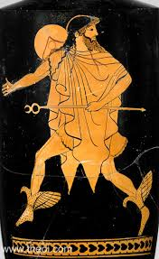

**Help line**

**μητηρ mother**

**πατηρ father**

|  |
| --- |
| **Need an extra challenge?**  Also use the verb "to be" in your answer.  He/She/It is = ἐστι |

**ἀδελφη sister**

**ἀδελφος brother**

**θυγατηρ daughter**

**υἱος son**

**παιδιον child**