The Greek alphabet

Write the letters the teacher dictates on this grid.

You may team up with your neighbour.

|  |  |  |  |  |
| --- | --- | --- | --- | --- |
|  |  |  |  |  |
|  |  |  |  |  |
|  |  |  |  |  |
|  |  |  |  |  |

**Subject or Direct Object?**

**Circle the correct word in each sentence.**

* + - 1. 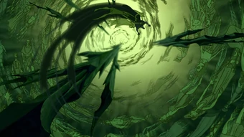I pick up a stick from the ground and I chase away the ψυχη / ψυχην.

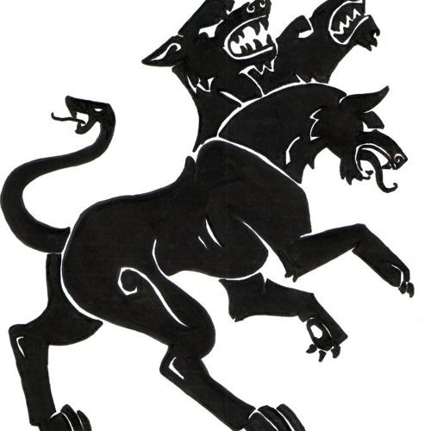

* + - 1. Κερβερος / Κερβερον is the three-headed dog that guards the underworld.
      2. The Μινωταυρος / Μινωταυρον gives a loud roar.

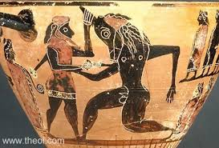

* + - 1. The sea monster has swallowed a παιδιον / παιδιον.
      2. Ἀριαδνη / Ἀριαδνην is eating a honey biscuit.
      3. Ἁιδης / Ἁιδην is the god of the underworld.

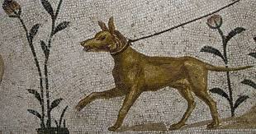

* + - 1. Odysseus loves his dog Ἀργος / Ἀργον.

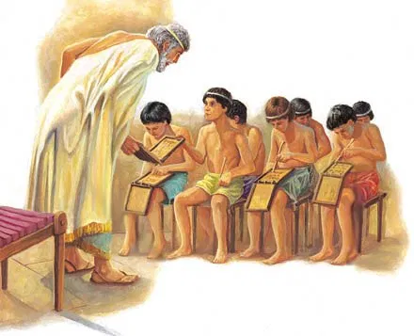

* + - 1. I like going to the σχολη / σχολην, because I like learning new things.

**This is how it works:**

|  |  |
| --- | --- |
| Subject | Direct Object |
| Ἀριαδνη | Ἀριαδνην |
| Μινωταυρος | Μινωταυρον |
| Παιδιον | παιδιον |

**EXTRA EXERCISES**

1. **Write these words in Greek**

For example: chaos = *χαος*

* bios = ……………………………………………………….
* auto = ………………………………………………………
* atlas = ………………………………………………………
* biblion = ……………………………………………………
* mikron = ……………………………………………………
* mega = ……………………………………………………..
* paidion = ………………………………………………….
* Europè = ………………………………………………….. (o = omicron, è = eta)

1. **Write these words in English**

For example: ἀτομος = *atomos*

* θερμος = …………………………………………………..
* νικη = ……………………………………………………………...
* καππα = …………………………………………………………..
* Ζευς = ……………………………………………………………..
* Ἀθηνη = …………………………………………………………..
* Ἑλλας = …………………………………………………………..
* στρατηγος = …………………………………………………….
* Μινωταυρος = ………………………………………………….
* Ποσειδων = …………………………………………………….

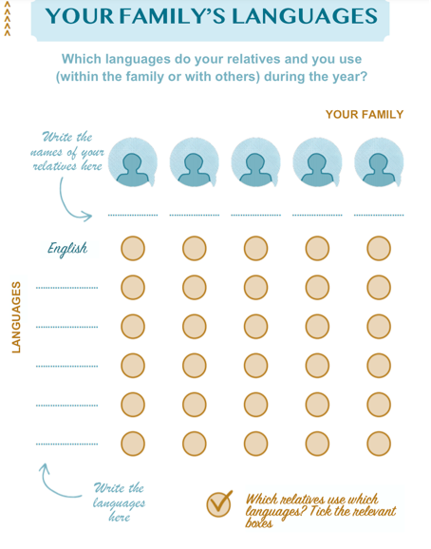

Source: Talenpaspoort, Onderwijscentrum Ghent, see <https://meertaligheid.be/content/4-onderzoek/talenpaspoort-gezin.pdf>