**Sindbad and the giant**

1. In pairs: What do you remember of the story of Sindbad and the giant? Use the text to find your answer.

________________________________________________________________________

________________________________________________________________________

________________________________________________________________________

________________________________________________________________________

________________________________________________________________________

________________________________________________________________________

* How does the giant look like? (tip: use Greek words in your explanation.) You can also draw the giant if you like.

________________________________________________________________________

________________________________________________________________________

________________________________________________________________________

________________________________________________________________________

* Which plan does Sindbad figure out?

________________________________________________________________________

________________________________________________________________________

________________________________________________________________________

1. In pairs: What would you do if you were the giant? Would you also devour Sinbad’s friends or would you be a friendly giant? 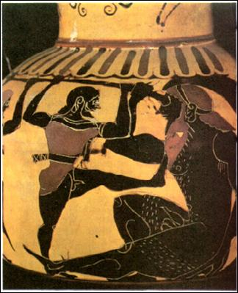

__________________________________________________________

__________________________________________________________

__________________________________________________________

__________________________________________________________

__________________________________________________________

__________________________________________________________

C) Do you approve of what Sindbad does? Why (not)?

What would you do if you came across a giant?

________________________________________________________________________

________________________________________________________________________

________________________________________________________________________

________________________________________________________________________

________________________________________________________________________

________________________________________________________________________