Introduction of The Arabian Nights and Sinbad + General info to slides
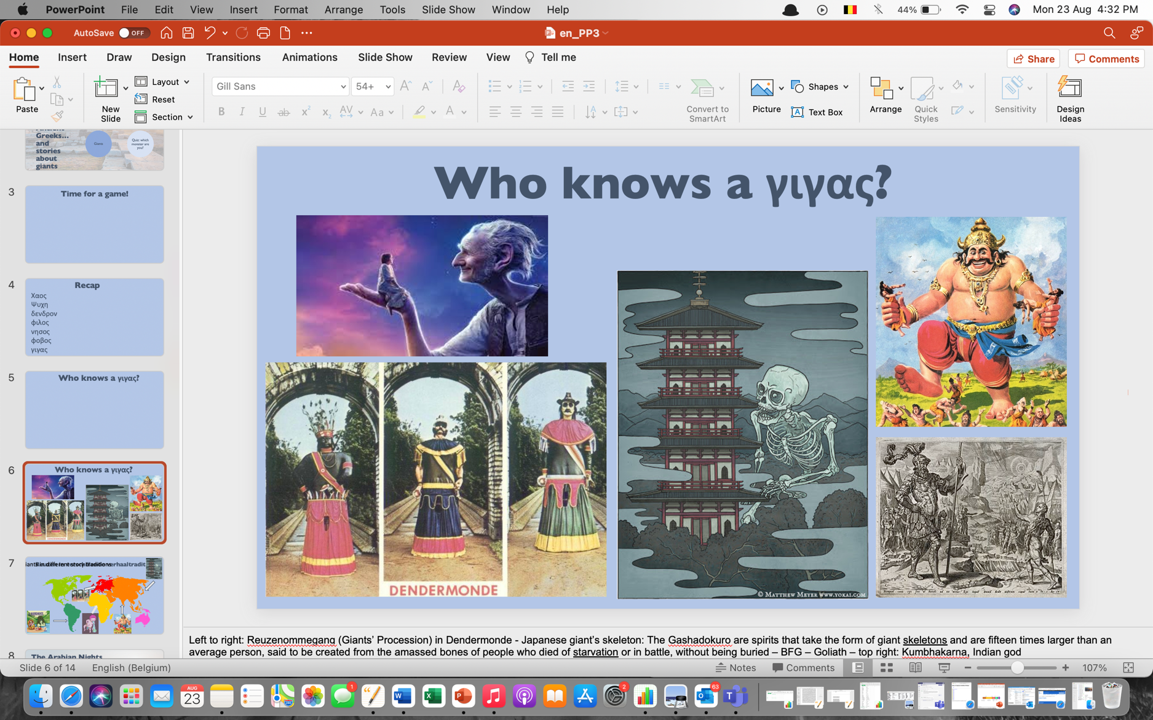

Top left: from the BFG, film adaptation of Roald Dahl's book about the Big, Friendly Giant
Bottom left: giants from the annual giants’ procession of Dendermonde (or insert another town): 'Dendermonde is not only known for its ten-yearly Ros Carillon Procession. Every last Thursday of August, the three historical giants of the guild, Indian, Mars and Goliath, dance through the city centre as the protagonists of their own circumambulation 'Katuit'.
Middle of ppt: the Japanese ghost Gashadokuro, which consists of a gigantic skeleton of all the people who died without burial.
Top right: Kumbhakarna, Indian god, ravenous, always wanted to eat
Bottom right: giant Goliath from the Bible, was defeated by David

Bottom left: Madremonte, South-American spirit/goddess who protects nature
Above in the middle: Dendermonde procession
Bottom middle: Mbombo from Congo, surrendered the world
Bottom right: Indian god (previous slide)
Top right: Japanese god (previous slide)
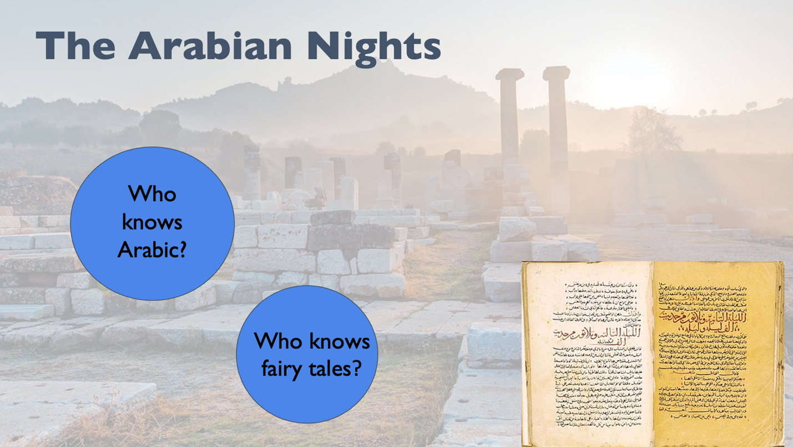
Introduction of The Arabian Nights: important collection of stories from the Middle East, ask if anyone is familiar with it, if not: tell the pupils that it's about a horrible king who sends different women to his palace every night and kills them after that night. One day, a girl comes along and wants to outwit him. The stories that she tells him are so exciting that he decides he cannot kill her and sends for her again the next night. This goes on for 1,001 nights, and in the end the king does not kill her because he has become attached to her. One of the stories she tells him, among others, is the story of Sinbad, the tough sailor.
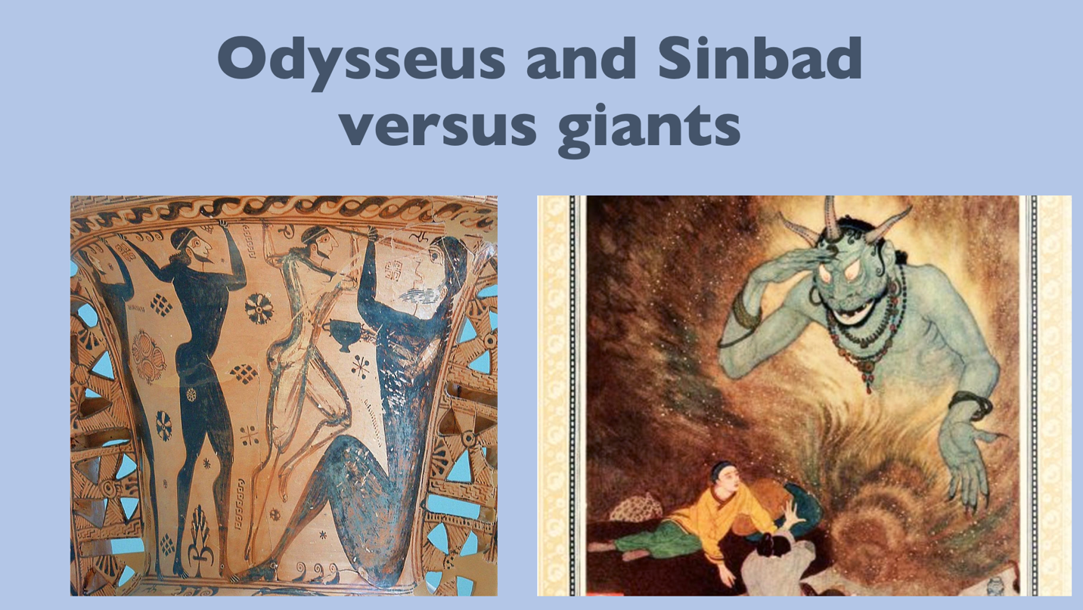

So what does all this have to do with ancient times? More than you might think! In Greek mythology, we find someone very similar to Sinbad, namely Odysseus! Their experiences ran very parallel, both involving a giant and we’re going to read about them together!
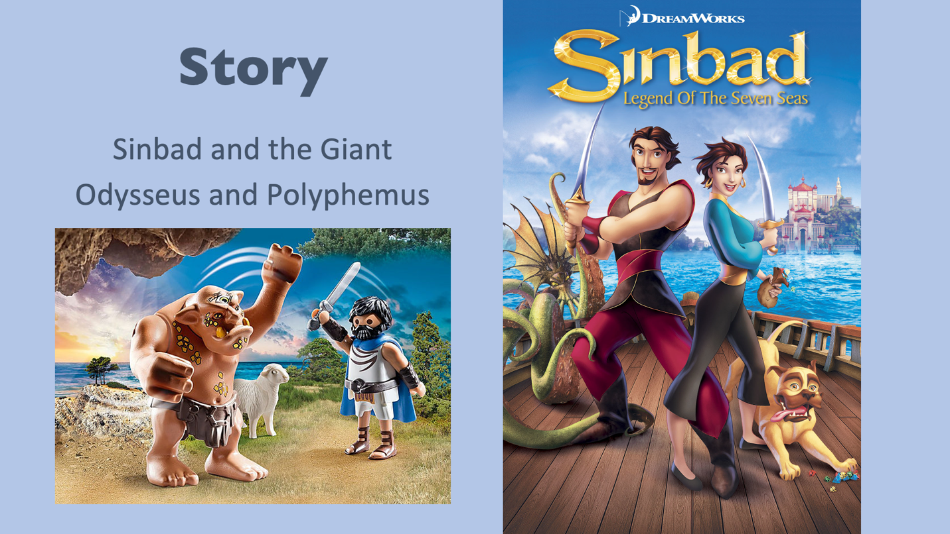

You may have heard of Playmobil? The Odysseus and Polyphemus version? Or the Dreamworks film about Sinbad? If not, let's get to the story...

